1.68:a)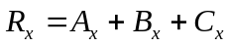 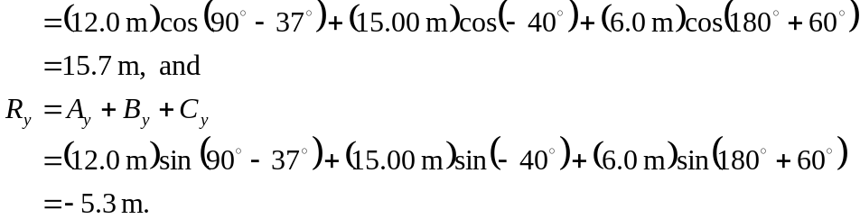

The magnitude of the resultant is 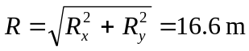, and the direction from the positive x-axis is arctan 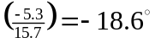. Keeping extra significant figures in the intermediate calculations gives an angle of 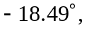 which when considered as a positive counterclockwise angle from the positive x-axis and rounded to the nearest degree is 

 